
Revista de Comunicación y Salud, Year, Vol. _, pp.
Edited by the Chair of Communication and Health
ISSN: 2173-1675

Review

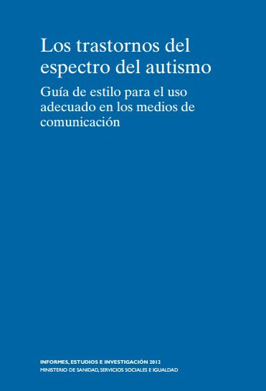

Book title
(Times New Roman 14, bold, italic, left-aligned, single-spaced)

Author: (of the book being reviewed. First and Last Name, Times New Roman 12, left-aligned, single-spaced)
Editorial:
ISBN:
Number of pages:

Image of the book cover

Reviewed by: (First and Last Name, Times New Roman 12, left-aligned, single-spaced)
Affiliation, Country.
(Times New Roman 12, left-aligned, single-spaced)

How to cite the article: (APA 7th Edition)
Last Name, N., & Last Name, N. (year). Article title. Revista de Comunicación y Salud, ##, pp. (Times New Roman 12, justified) . https://doi.org/10.35669/rcys.year.Vol.ID (assigned by the editor)

Text text text text text text text text text text text text text text text text text text text text text text text text text text text text text text text text text text text Text . (Times New Roman , 12, normal, justified, single line spacing)

Text text text text text text text text text text text text text text text text text text text text text text text text text text text text text text text text text text text Text . (Times New Roman, 12, normal, justified, line spacing) simple )
Text text text text text text text text text text text text text text text text text text text text text text text text text text text text text text text text text text text Text . (Times New Roman, 12, normal, justified, line spacing) simple )
Text text text text text text text text text text text text text text text text text text text text text text text text text text text text text text text text text text text Text . (Times New Roman, 12, normal, justified, line spacing) simple )
Text text text text text text text text text text text text text text text text text text text text text text text text text text text text text text text text text text text Text . (Times New Roman, 12, normal, justified, line spacing) simple )

Text text text text text text text text text text text text text text text text text text text text text text text text text text text text text text text text text text text Text . (Times New Roman , 12, normal, justified, single line spacing)

Reviewer
Name and Surname (Times New Roman 12, left-aligned, single-spaced)
Affiliation (Times New Roman 12, left-aligned, single-spaced)
email@gmail.com

Curriculum vitae summary of no more than 120 words.

ORCID:
Google Schools :
Research Gate:
Scopus:

